ATU-10 (vk3pe) PCB assembly. (8th Oct 2021)

Intro:

This PCB is based on the ATU-10 board designed by N7DDC. The only variation for the boards by vk3pe is that the two PIC devices are now a larger physical type. This achieves two things:

1. Easier to find parts. Both devices are in reasonable supply from the usual outlets at time of writing. The originals are impossible find.
2. Easier to solder. Being larger and with wider spaced pins, means both are much easier to solder down.

The PCB is designated Version “1.2”. It was designed by circuit tracing the original PCB by N7DDC in August of 2021. Since there was never an official Schematic ever available from N7DDC, then it must be accepted that there might be some errors. However, having built two PCB’s, there have been no faults found in this version.

N7DDC has released a relay test program which enables the finished board to be tested to confirm that all the relays operate as expected. It is highly recommended to use this program before putting the ATU into service. N7DDC’s information on this project is at [his Github.](https://github.com/Dfinitski/ATU-10-10W-QRP-antenna-tuner) Goto the Firmware section for the test program and the other Files required.

Assembly:

This is not a part by part assembly document although it seems I wrote more than I intended! It assumes some basic knowledge at least of reading Schematics, finding parts references in the Bill of Material and soldering skills. Not mention sourcing all the parts needed. I have also provided an overlay of the PCB showing parts by value. There is no need to be frightened of smd assembly if this is your first attempt at it. In fact it’s recommended that builders checks out various YouTube videos on this subject before assembling this PCB if you have no smd experience. You only need basic tools. No ovens, heat guns etc are needed.

In the shack here, a 20+year old Hakko926 soldering iron is used, but with a very fine pointed tip. Don’t use some old tip you have been using for some time, get a fresh one. Tweezers are needed to pick up the parts. Plus the usual small hand tools. A magnified desk lamp or headset are handy. Make sure you have spares of the smaller parts, as sometimes you may lose them from the tweezers and they are stupidly hard to find on the floor!

The Case

The V1.2 PCB was designed to suit three different case types. 100x71mm as per N7DDC original, 100x82mm or 100x88mm. There are lines marked on the PCB which designate where the board should be cut to suit each case size.

* For the 100x71mm case, cut the tabs off entirely. It is prudent though to cut a little less and check with the actual case you have.
* For the 100x82mm case, the V1.2 PCB markings are INCORRECT due to not having an actual case to check the sizing at the time. The case only arrived on the 6th Oct 2021 and is narrower internally than though. Actual width to cut the PCB should be 75.5mm. This is about 1.5mm on the inside of the central cut marks on each tab on both sides of the V1.2 PCB, but measure first against your case.

*The PCB will be updated to V1.21 to correct the cut line for 82mm case.*

* For the 100x88mm case, no case is available here either so check carefully. Kees, K5BCQ reports no problems with the 88mm wide case though.

**The PCB must be cut before any assembly begins. Repeat: check your case BEFORE cutting the PCB !**

Recommended assembly sequence:

It’s prudent not to fit the PICs or dual FET devices, before testing the 3v3 regulator first. Assemble all the small components around the regulator area, the TP4056 (no 14500 cells yet) and then check the regulator actually outputs 3.3v or close to it. Plug in the USB cable to the PCB and your PC and with a voltmeter, check that the regulator output is actually 3.3v. If not, find the problem.

Only then can you proceed with other parts. Fit the dual FET devices first as its difficult to fit them if the capacitors adjacent to them are fitted. Note there is a tiny ‘dot’ on the PCB which designates pin 1 of the FET. When you fit the FET make sure it’s dot aligns with the PCB dot. It can be very hard to see the dot on the FET. I suggest only soldering ONE pin of each FET so you can double check orientation again. You may need a magnifier and try the FET at different angles to see the dot. (The BAT41 diodes are similar, hard to see the bar at the cathode end)

Then you can fit all the other parts except the relays, toroids, SWR ferrite and BNC sockets. Fit the header pins for the OLED and J1 & J4. (J5 is not fitted.) Don’t fit the links on J1 & J4 yet. Unless you are going to use the dual LED’s, don’t bother fitting LED1 & LED2 header pins. Wait until the end of the build to fit the 3.5mm socket. You need to carefully straighten the pins on the socket with pliers to fit into the PCB.

If using the OLED display, a short cable will be needed to connect it to the PCB. In this build, header pins were fitted to the OLED also so a short cable with header receptacles (socket) needs to be made. This is the cable used, assuming use of a standard case. It’s a good idea to identify the “Vcc” wire in the cable so that you orient the cable correctly on the OLED and PCB. I used red heat shrink as you can see. The cable is made from an offcut from a piece of ribbon cable. This is the cable for the standard 71mm wide case. Other cases may require a longer cable.

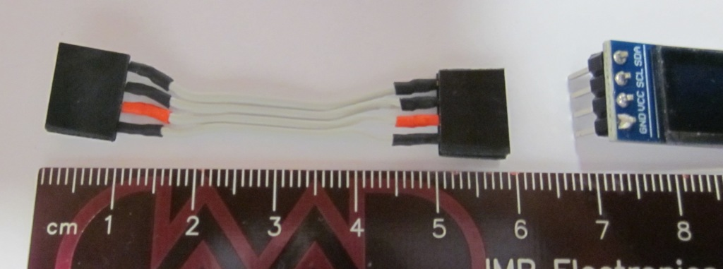

Then you can fit the PIC16F1454 device. It’s a SOIC-14 footprint and easy to solder, use a minimum of solder though. DON’T fit the other PIC yet. Check orientation.

Programming the Firmware

Now the PIC can be programmed. You will need a Pickit3 or Pickit4 or equivalent which can be found on eBay etc. The Pickit2 might work, I don’t know.

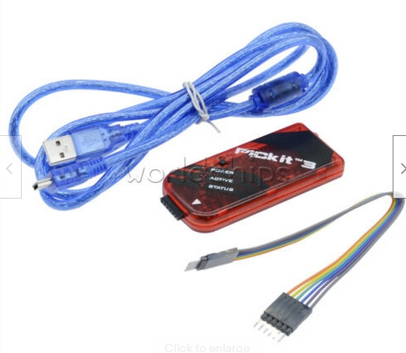**This is a typical “clone Pickit3”**

Connect the programmer to the ICSP pins. Observe the pin numbers, pin 1 of the Pickit (white triangle) goes to pin 1 of the ICSP connector on the board which is marked with a “1”. (It’s also a square pad) Note pin 6 is not used. I just fit header pins in the holes without soldering them as it’s only needed once. Maintain a bit of sideways pressure on the pins to ensure contact while programming.

Plug the Pickit into the ATU-10 ICSP as above using a USB port on your PC.

Plug another USB cable into your PC and into the ATU-10.

Run the AP, Microchips “MPLAB X IPE v5.45” (earlier versions might also work.) available from the Microchip web site.

Select the PIC16F1454 as below: (down the page)

Click on the “Connect” button and you should see a dialogue with ‘connected’ shown. Ie the PIckit is connected.

Click on the “Browse” button and navigate to the “raw_1454.hex” file on your PC. (Downloaded from Github)

Click on the “ERASE” Button, wait a few seconds, then “PROGRAM”. After a few period, the PIC16F1454 should be programmed. You only ever need to do this once as all updates after this to Firmware are done via a copy/paste, details below which is below.

Disconnect the USB cable.

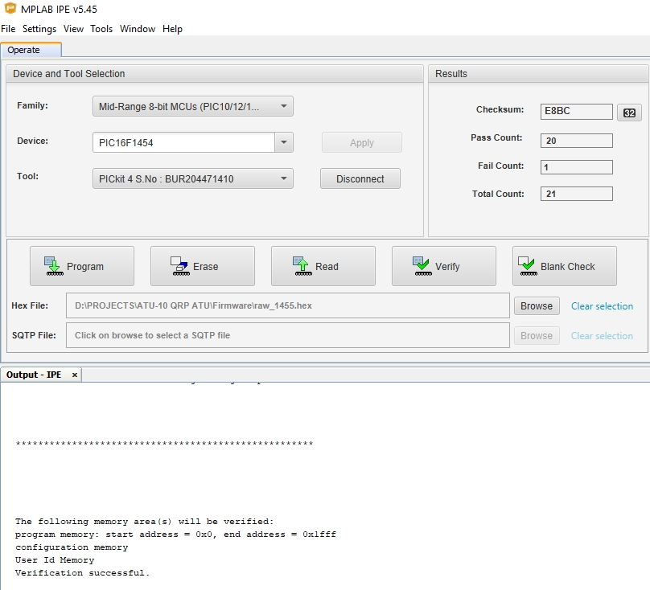

Now fit the PIC16F18877 device. And plug the ATU-10 back into your PC USB. A window should pop up on your PC with a file “README.HTM” Don’t bother to read it, that’s not required.

By now you should have copied the Firmware file from N7DDC’s Github for the latest ATU-10 version. Unzip the ZIP file. Eg “ATU_FW_V12.HEX” (As of writing, the actual latest firmware is V1.3 but the downloaded file just says “ATU-10.HEX”)

Select the .HEX file with your mouse (left mouse click etc) and then paste it (right click) into the Window that popped up with the README.HTM

A new ‘progress bar’ window will pop up for a few seconds and the PIC16F18877 is now programmed! If not, the most likely cause is that the 2 connections from the USB socket and PIC16F18877 have a dry joint.

Unplug the USB cable and connect the OLED display using the cable made as above. ENSURE that the Vcc connection is correct on the OLED and the OLED header pins on the ATU-10.

Plug the USB cable back in and the OLED should spring to life !!

A short press on the front panel button should show “RESET” on the display. A longer press should say “TUNE”.

Now, you need to load the rest of the parts. The relays are a bit tricky as you need to carefully straighten all the pins first using fine tipped needle nosed pliers. I fitted all the relays at once but turning the PCB over, you are bound for many if not all to fall out. Not good. (Ask how I know)

Before turning over, place a piece of scrap PCB over the relays, to hold them all down, turn over the PCB very carefully ensuring no relays fall out. Solder using a long tipped fine tip ONE pin on each of the relays. No need to fill the holes, just make sure the solder seems to wick down into the hole as the relay pins are very short.

Turn the board back over, no relay should fall out but if you observe them carefully they may not all be sitting flat on the PCB. To correct this, stand the PCB vertically with the solder side toward you, place your finger on each relay in turn and re-melt that ONE pin you soldered. The relays should then sit flatter. Repeat for all. ONLY when happy with the fitment, solder the rest of the pins. I repeat, ONLY when happy with fitting, solder the rest of the pins. It won’t be easy if you have to remove them.

Now you can wind and fit the toroids and balun core for SWR section. Remember, EACH wire through the toroid is ONE turn. If you want to be pedantic and have an inductance meter, you could measure each inductance before fitting. Not really needed I think.

Fit the BNC connectors. Solder the central pin first then check the connector is at right angles out of the PCB. If nit, heat up the pin and correct. Solder one ground pin and check again. I just soldered two opposite ground pins on my build.

Before fitting the 14500 cells, check the output of the TP4056 at pin 5. It should be about 4-4.2Vdc. Then you can fit a link on J1 header. This connects the Cells to the TP4056.

Once the cells are fitted you can monitor the charge current if you have a USB in-line voltmeter/current meter ‘gadget’ available on eBay. Charge initially will be about 350-400mA steadily dropping to about 10mA trickle charge.

However, it’s best if the cells are both in the same charged condition before fitting if possible. I temporarily fitted each cell in turn to the ATU-10 board and allowed them to fully charge first. i.e. Charge current eventually reduced to about a 10mA trickle rate. Make sure you fit them with the correct polarity! The ones I bought don’t have an obvious +ve end. (Use a digital multimeter for this and mark the Positive end to avoid confusion and smoke!) Then fit the now fully charged cells to the board. A piece of stiff copper wire can be used fitted into the PCB and soldered to the cells. To reduce any risk of damage to the cells by soldering them, I bought cells with solder tags on them.

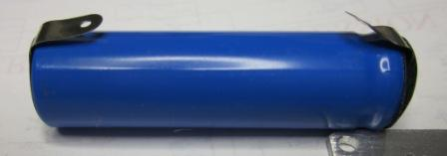

TESTING

Refer to N7DDC’s [Github page](https://github.com/Dfinitski/ATU-10-10W-QRP-antenna-tuner) for details of operations.

At this stage it’s a good idea to check if all relays actually operate correctly. David, N7DDC, has provided a **test program**, “Relay_Test.ZIP” on his Github page under ATU-10 Firmware, which allows the builder to test operation of each relay in turn, using the button on the front panel to cycle through the relays. Operation of the program is self-explanatory on the OLED screen. Use the same procedure as above, to load this test software.

I won’t detail the whole sequence except to briefly say how I verified the relay operation. When you run the test program you need to RESET all relays to the normal condition which is how the contacts are shown on my Schematic. Using an ohm meter in continuity mode (ie buzzer) , place it across the appropriate pins of the relay being tested to see if the relay actually changes state. Repeat for each relay.

Once all relays have been verified for operation, reload the latest Firmware. And…………….

**Happy tuning**

Vk3pe

Just a short note on Parts for this project

I bought a resistor pack from eBay for the 0603 parts. Plenty of them with left overs for your “junk box”. If you buy just parts specified in the BOM, make sure you order extra parts. SMD parts have a habit of getting easily lost!

**80 Value 4000pcs 0603 SMD SMT 1% 10 ohm -910K ohm RESISTOR Assortment Kit**

**I didn’t check on the 0603 capacitors as I had most of them already. I did though buy the 250v and some other capacitors from Farnell/Element14 but the BOM by N7DDC lists Digikey numbers for most of the parts.**

There are world-wide shortages of components, especially IC’s and semi-conductors. You may need to do some hunting to find some parts in stock.

Both PIC devices in the packages used on the PCB are readily obtainable from Mouser, Digikey and Farnell (Newark) and maybe Microchips on-line shop.

There are three types of Dual FET devices that can be used. See N7DDC or my BOM.

I bought AO6604 devices from Utsource.com at about US$00.13 each (100) plus shipping.

Relays IM41 are usually available from suppliers above but much cheaper at 10 for US$10 on eBay. Buy 2 lots. Get them as soon as you can as they may run out.